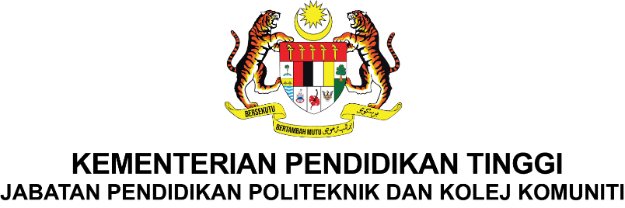

**DEPARTMENT OF INFORMATION AND COMMUNICATION TECHNOLOGY DIPLOMA OF INFORMATION TECHNOLOGY**

**( DIGITAL TECHNOLOGY )**

**DFT 50114 – INTEGRATED PROJECT**

**OKU BOOKING TRANSPORT SYSTEM**

**PREPARED BY:**

|  |  |  |  |
| --- | --- | --- | --- |
| **NO** | **NAME** | **NO MATRIX** | **CLASS** |
| 1 | NOOREMYLIA ERNA BINTI ABDULLAH @ ISMAIL | 12DDT23F1041 | DDT5A - S |
| 2 | NUR FATIN NASUHA BINTI JEFRY | 12DDT23F1032 | DDT5A - S |
| 3 | WAN NUR EIZLEEN FITRI BT WAN AZIZ | 12DDT23F1054 | DDT5B - S |

**SUPERVISOR:**

**ABDUL HALIM BIN AHMAD**

**SESSION:**

**II : 2024/2025**

**CONTENT**

|  |  |  |
| --- | --- | --- |
| **NO** | **TITLE** | **PAGE** |
| **1** | **INTRODUCTION** | **3** |
| **2** | **PROBLEM STATEMENT** | **4** |
| **3** | **OBJECTIVES** | **5** |
| **4** | **SCOPE** | **6 - 7** |
| **5** | **FRAMEWORK** |  |
| **6** | **PROJECT SIGNIFICANCE** |  |
| **7** | **LITERATURE REVIEW** |  |
| **8** | **METHODOLOGY** |  |
| **9** | **REFERENCES** |  |
| **10** | **GANTT CHART** |  |
| **11** | **FLOW CHART** |  |
| **12** | **COST PLANNING** |  |
| **13** | **CONCLUSION** |  |

1. **INTRODUCTION**

Transportation plays a crucial role in ensuring accessibility and independence for all members of society, including Persons with Disabilities (OKU). In Kuala Terengganu, many OKU individuals face challenges when arranging suitable transport, especially when needing vehicles equipped with wheelchair access or requiring special assistance. Current public transport options are often limited, lack scheduling flexibility, and do not provide real-time tracking. This project proposes the development of an OKU Transport Booking System with GPS integration to help OKU passengers book rides that's suitable for their disabilities easily, track drivers in real-time, and communicate accessibility needs directly to service providers. The platform will cater to passengers, drivers, and administrators, aiming to bridge the accessibility gap and improve the mobility experience for the OKU community.

1. **PROBLEM STATEMENT**

        Persons with Disabilities (OKU) in Kuala Terengganu face significiant challenges in accessing safe, reliable, and accessible transportation that meets their diverse needs. Most public transport services are not wheelchair-friendly, lack specialized facilities, and do not allow pre-booking based on accessibility requirements. As a result, OKU passenger often encounter long waiting times, uncertainty about vehicle readiness, and difficulties communicating their needs to drivers. Existing ride-hailing platforms also do not prioritizes OKU-friendly vehicles or provide options to specify accessibility needs during booking.

       In addition to these challenges, there are no additional services such as assistance in purchasing groceries, audio guidance for the blind or visually impaired, and complete information about drivers and vehicles makes travelling more difficult for OKU passengers. They are unable to choose suitable vehicles, such as MPV’s for wheelchair access, while vehicles modifications and driver training specific to handling OKU passengers remain limited. From a perspective, the absence of feauture such as SOS buttons, emergency service integration (e.g.,999), and district-based monitoring further limits the reliability of current transport solutions.

         Moreover, payment methods remain limited due to the lack of e-wallet integration, and many drivers lack awareness of the seven categories of OKU,creating communication gaps and unmet needs.This lack of inclusivity also affects elderly passengers who face mobility challenges and would greatly benefit from supportive transport services. Therefore, there is an urgent need for a dedicated transport booking platform that is inclusive, safe and equipped with accessibility features,transparent driver and vehicle information, flexible payment methods, and specialized support for both OKU and the elderly. Such a platform would significantly enhance confidence, independence, convenience, and safety for all users.

1. **OBJECTIVES**

* To ensure that at least 80% of registered OKU passengers can complete a booking without assistance during usability testing.
* To implement GPS tracking for real-time ride location and estimated time of arrival (ETA) updates.
* To allow OKU passengers to select vehicle types based on specific accessibility needs (e.g., wheelchair ramp, low-floor).
* To enable drivers to receive and manage ride requests efficiently through a mobile interface.
* To provide an administrator dashboard for managing users, bookings, and driver registrations.
* To store booking history for users and drivers to ensure transparency and service tracking.

1. **SCOPE**
   1. **User Scope:**

* Create an account and log in system.
* Book a ride by selecting pickup and drop-off locations.
* Choose vehicle type according to accessibility needs (e.g., wheelchair ramp, wide doors).
* View driver details before accepting the ride.
* Track the driver’s location in real-time via GPS.
* Receive estimated time of arrival (ETA) updates.
* View booking history and receipts.
* Provide ratings and feedback after the ride.
* Use accessibility features such as audio guidance for blind or visually impaired users.
* Make payments via multiple methods including e-wallet integration.

1. **Driver Scope :**

* Create an account and upload verification documents(e.g., driver’s license, OKU transport certification).
* Receive and manage ride requests.
* Use integrated GPS navigation for route guidance.
* Update ride status(e.g., “On the way”,”Arrived”,”Completed”).
* View ride history and earnings report.
* Receive training modules or guidelines on 7 categories of OKU to better understand passenger needs.
* Provid services extensions(e.g., assist OKU passengers for groceries or mobility support).
* Display vehicle accessibility features clearly to passengers.

1. **Admin Scope:**

* Approve or reject passenger and driver registrations.
* Manage and update vehicle accessibility details.
* Monitor real-time GPS tracking of rides for safety.
* Handle user complaints and disputes.
* Generate reports on bookings, user activity, and service performance.
* Manage system updates and security.
* Configure district-based user management within Kuala Terengganu.
* Review and validate driver training on handling OKU categories.

1. **Supervisor Scope:**

* Guide project development to meet OKU accessibility standards.
* Review system usability and suggest improvements.
* Ensure compliance with local transport and disability regulations.
* Monitor progress of system testing and deployment.
* Oversee implementation of safety features (SOS button, district monitoring).
* Recommend additional inclusivity features(e.g., elderly support, grocery service assistance.

1. **FRAMEWORK**
2. **PROJECT SIGNIFICANCE**

    The **OKU Booking Transport System** plays a vital role in improving mobility, accessibility, and inclusivity for Persons with Disabilities (OKU) in Kuala Terengganu. By offering a platform that allows OKU passengers to book rides tailored to their accessibility needs, this project addresses a critical gap in current transportation services. The integration of GPS tracking enhances safety and convenience by enabling real-time monitoring of ride locations and estimated arrival times.

     For drivers, the system streamlines the process of receiving and managing bookings, ensuring better service efficiency and reducing miscommunication. Administrators benefit from a centralized dashboard to manage users, drivers, and bookings, which promotes operational transparency and service quality.Additional features such as e-wallet payments, SOS button, and emergency monitoring also improve safety and service efficiency.

     In the broader community context, the project supports the creation of a more inclusive public transport ecosystem, reducing social and mobility barriers faced by the OKU community. It also sets a precedent for technology-driven accessibility solutions that can be replicated in other regions, ultimately contributing to a more equitable society.

1. **LITERATURE REVIEW**
2. **METHODOLOGY**

We are using the Agile Model to develop the OKU Booking Transport System because it allows us to break the project into smaller tasks, deliver working parts early, and improve them based on feedback.

Our Agile process has 6 steps repeated in each sprint:

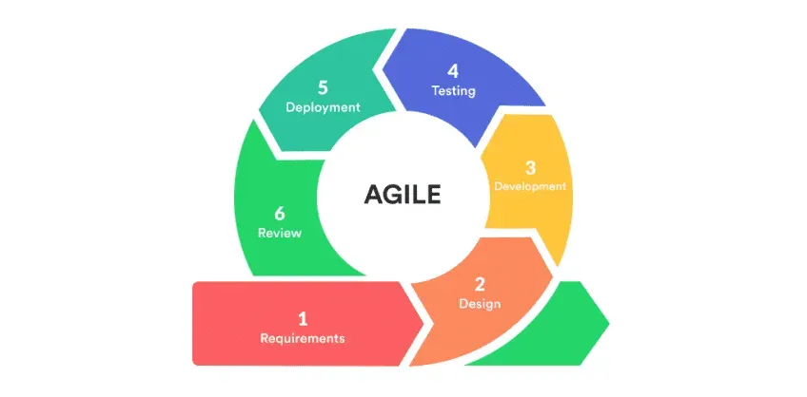

Step 1 – Planning

* Discuss with supervisor and group members.
* Collect requirements from OKU passengers and drivers (basic needs, accessibility options).
* Decide which features will be developed in the current sprint.

Step 2 – Design

* Create simple interface sketches (UI mockups) for passenger, driver, and admin.
* Plan the database tables and basic system flow.
* Choose tools (MIT App Inventor / Android Studio, MySQL, PHP, 000webhost).

Step 3 – Development

* Code the selected features for the sprint.
* Connect the mobile app to the database.
* Example: In Sprint 1, build login/register; in Sprint 2, booking form; in Sprint 3, GPS tracking.

Step 4 – Testing

* Test the features developed in the sprint on a test phone.
* Check for errors such as wrong booking details or GPS not updating.
* Get feedback from supervisor or test users.

Step 5 – Deployment

* Upload the latest working version to hosting (000webhost) so it can be tested online.

Step 6 – Review & Feedback

* Discuss with supervisor and users what works well and what needs improvement.
* Record changes needed for the next sprint.
* Start again at Step 1 with improved features.

1. **REFERENCES**
2. **GANTT CHART**
3. **FLOW CHART**

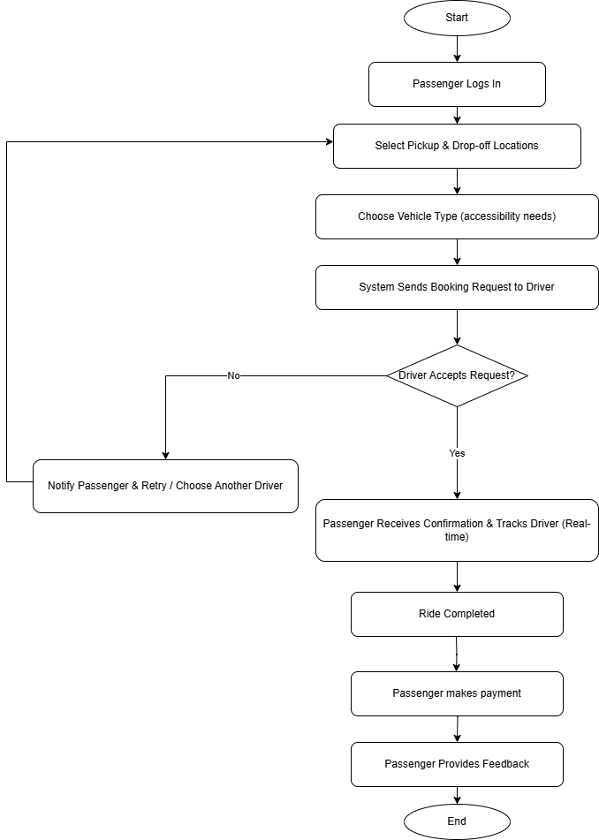

1. **COST PLANNING**

|  |  |  |
| --- | --- | --- |
| **Item** | **Description** | **Cost (RM)** |
| Domain & Hosting | 1-year student hosting package | 80 |
| Development Tools | Open-source software (VS Code, XAMPP) | 0 |
| Database Server | Free MySQL on hosting | 0 |
| Total |  |  |

1. **CONCLUSION**

The OKU Booking Transport System is designed to provide a more accessible, reliable, and user-friendly transportation booking service for Persons with Disabilities (OKU) in Kuala Terengganu. Through GPS integration, vehicle accessibility options, and real-time tracking, the system addresses the major challenges faced by OKU passengers, such as uncertainty in transport availability and difficulty communicating accessibility needs.This ensures that OKU passengers in Kuala Terengganu can travel with greater confidence, safety, and independence.

During development, the Agile methodology allowed us to complete the system in small, manageable stages and incorporate feedback from users and our supervisor. This ensured that the core functions — passenger booking, driver management, admin monitoring, and GPS tracking — were implemented efficiently within the 3-month project timeline. The use of Agile alse helped the team remain flexible to changes, making the system more practical and closely aligned with real user needs.

Although the system is currently at the prototype stage, it demonstrates the potential to be expanded into a fully functional public service platform. In the future, enhancements such as in-app payment integration, advanced accessibility preferences, and multi-language support could make the platform even more beneficial to the OKU community.This prototype therefore acts as a foundation for future development, proving that technology can play an important role in supporting inclusivity and improving quality of life.

By successfully completing this project, our team has not only applied technical skills in web and mobile development but also contributed towards building a more inclusive society through technology.This achievement highlights the importance of innovation in solving social challenges, particularly for marginalized groups such as OKU in Kuala Terengganu.